**LC=Lynnette Carter**

**KK=Kim King**

**SS = Stephanie Solazzo**

**RP = Rachel Peaks**

SH = Sherri Haggerty

**HM = Heather Manire**

**EN = Erin Nunley**

**BD = Brooke Diaz**

**MD = Madison Perkins**

**TS = Terri Skipper**

**AL = Aliza Lee**

**Li**

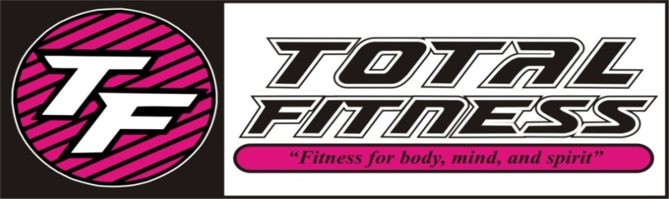

***JUNE 2016 CLASS SCHEDULE***

|  |  |  |  |  |  |  |
| --- | --- | --- | --- | --- | --- | --- |
| TIME | MONDAY | TUESDAY | WEDNESDAY | THURSDAY | FRIDAY | SATURDAY |
| 8:30 AM | **(SS) Yoga Fitness** | **(LC) Pure Strength** | **(AL) Zumba** | **(LC) Pure Strength** | **(AL) Zumba** |  |
| 9:30 AM | **(SS) SS Yoga** | **(RP) SS Circuit** | **(LC) SS Classic** | **(RP) SS Cardio** | **(SH) SS Classic** | (TS) Pound |
|  |  |  |  |  |  |  |
| 10:30 AM | **(AL) Zumba Gold** | **(RP) House Party Fitness** | **(LC) Classical Stretch** | **(RP) House Party Fitness** | **(SH) Classical Stretch** | **(EN) Zumba Toning** |
|  |  |  |  |  |  |  |
| 10:30 AM | **(SH) Water Aerobics** |  | **(SH) Water Aerobics** |  | **(AL) Aqua Zumba** |  |
|  |  |  |  |  |  |  |
| 4:00 PM |  | **(MP) Kids Aerobics** |  | **(MP) Kids Aerobics** | **(MP) Kids Aerobics** |  |
| 5:30 PM | **(SS) Yoga** |  | **(SS) Yoga** |  |  |  |
| 6:00 PM |  | **(KK) Fat Blaster** |  | **(KK) Fat Blaster** | **(EN) Zumba** |  |
| 7:00 PM | **(HM) Zumba** | **(HM) Zumba** | **(TS) Pound** | **(BD) House Party Fitness** |  |  |

**SS Classic**-*Silver Sneakers* class- Muscle Strength & Range of Movement will help to improve agility, balance, coordination and activities for daily living, using a chair, ball, free weights, and bands.

**SS Yoga Stretch**-*Silver Sneakers* class will move your whole body through a complete series of seated and standing yoga poses designed to increase flexibility, balance and range of movement.

**SS Cardio Circuit**-*Silver Sneakers* All welcome this class will include strength training and range of motion with cardio intervals.

**Fat Blaster**-This class will blast fat cells and burn calories, using multiple disciplines including circuit, intervals, kickboxing, and step!

**Kids Aerobics**-A fun filled class to keep your child moving aerobically by playing games, dancing and challenging obstacle courses!

**Yoga**-Classes that will stretch your mind, body, and spirit, several modifications are taught to make your experience as relaxed or challenging as you like.

**Yoga Fitness**-A combination of yoga poses with small weights and movement.

**Zumba**-Latin inspired dance-fitness class with cardio-based dance movements that are easy to follow. No dance experience required!

**Zumba Toning**-Same dance add some light weights for extra toning.

**Zumba Gold**-This class is the Zumba you love modified at lower-intensity for the active older adult!

**Aqua Zumba**-Dance in the buoyant water so easy on your joints and loads of fun!

**House Party Fitness**-Enjoy hip hop beats with moves that target the areas of your body that you want toned, and the cardio will melt the fat away**.**

**Pure Strength**-Designed to build strength, add definition, increase bone density, and decrease body fat by increasing your lean muscle which will in turn speed up your metabolism. No muscles get neglected in this class!

**Pound**-Combines light resistance with constant simulated drumming movements torching 400 – 900 calories per class!

**Classical Stretch**-Rebalance your body, increase mobility and keep joints healthy with this full body dynamic stretching exercises.

**Water Aerobic**- Full body workout in the sun and fun! Enjoy the buoyancy of the water on the joints while strengthening the muscles and burning the calories!

*Water classes are subject to the weather conditions.