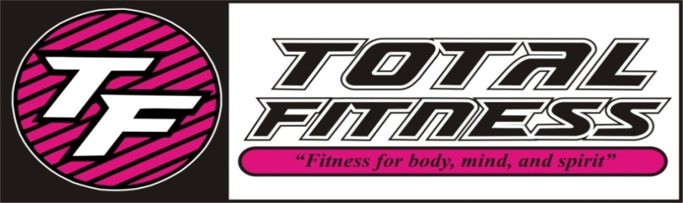

**LC = Lynnette Carter**

**KK = Kim King**

**SS = Stephanie Solazzo**

**RP = Rachel Peaks**

**JR = Jennifer Ridge**

**SW = Stephanie Wendorff**

**HM = Heather Manire**

**EN = Erin Nunley**

**KM = Kimberly Montgomery**

**BD = Brooke Diaz**

**MD = Madison Perkins**

***MAY 2015 CLASS SCHEDULE***

|  |  |  |  |  |  |  |
| --- | --- | --- | --- | --- | --- | --- |
| TIME | MONDAY | TUESDAY | WEDNESDAY | THURSDAY | FRIDAY | SATURDAY |
|  |  |  |  |  |  |  |
| 8:30 AM | **(SW) Tabata** | **(LC) Pure Strength** | **(JR) Shred** | **(LC) Pure Strength** | **(JR) Shred** | **\*starting 5-9\***  **(JR) Shred** |
| 9:30 AM | **(SS) SS Yoga** | **(RP) SS Circuit** | **(LC) SS Classic** | **(RP) SS Cardio** | **(SW) SS Classic** | **(SW) Mix and Max** |
| 10:30 AM | **(SW) Pure Strength** | **(RP) House Party Fitness** | **(SW) Tabata** | **(RP) House Party Fitness** | **(RP) House Party HITT** | **(EN) Zumba** |
|  |  |  |  |  |  |  |
| 11:30 AM |  | **(SS) Fitness Yoga** |  | **NOON (SS) SS Yoga** |  |  |
| 3:30 PM | **(JR) SS Circuit** |  |  |  |  |  |
| 4:00 PM |  | **(MP) Kids Aerobics** |  | **(MP) Kids Aerobics** | **(MP) Kids Aerobics** |  |
| 4:30 PM | **(JR) Shred** |  | **(JR) Core Commotion** | **(JR) Tabatta** |  |  |
| 5:30 PM | **(SS) Yoga** | **(JR) Shred** | **(SS) Power Yoga** | **(JR) Shred** | **(EN) Zumba** |  |
| 6:00 PM |  |  |  |  |  |  |
| 6:30 PM | **(SS) Core Commotion** | **(KK) Fat Blaster** | **(SS) Core Commotion** | **(KK) Fat Blaster** |  |  |
| 7:00 PM |  |  |  |  |  |  |
| 7:30 PM | **(HM) Zumba** | **(HM) Zumba** | **(KM) Zumba** | **(BD) House Party Fitness** |  |  |

**SS Classic**- *Silver Sneakers* class- Muscle Strength & Range of Movement will help to improve agility, balance, coordination and activities for daily living, using a chair, ball, free weights, and bands.

**Fat Blaster-** This class will blast fat cells and burn calories, using multiple disciplines including circuit, intervals, kickboxing, and step!

**Kids Aerobics**- A fun filled class to keep your child moving aerobically by playing games and challenging obstacle courses, they won’t even realize they are working out!

**Yoga, Flow, Fitness, & Power**- Classes that will stretch your mind, body, and spirit. Several modifications are taught to make your experience as relaxed or challenging as you like, **Fitness** add weights, **Power** adds all levels of challenges.

**SS Yoga Stretch**- *Silver Sneakers* class will move your whole body through a complete series of seated and standing yoga poses designed to increase flexibility, balance and range of movement.

**Zumba**- Latin inspired dance-fitness class with cardio-based dance movements that are easy to follow. No dance experience required!

**House Party Fitness-** Enjoy hip hop beats with moves that target the areas of your body that you want toned, and the cardio will melt the fat away**. On My Weigh**, is the same but easier. **Core** adds more core action.

**SS Cardio Circuit** – *Silver Sneakers* – All welcome this class will include strength training and range of motion with cardio intervals.

**Mix and Max** – Every class will mix up the cardio and max your individual intensity for a great high low work out! Never a dull moment.

**Core Commotion**-Core training through balance, flexibility, and multi-joint movement patterns, you will feel a real “commotion” in your core!

**Pure Strength**- Designed to build strength, add definition, increase bone density, and decrease body fat by increasing your lean muscle which will in turn speed up your metabolism. No muscles get neglected in this class!

**Tabata**-One of the most effective types of interval training through a variety of simple, yet intense timed exercises, each class will blast the calories and provide noticeable results in a short amount of time.

**Circuit Training**-An excellent boredom buster! Doing a variety of conditioning exercises you will turn your body into a calorie burning machine!

**Step Up**-A class using steps in a variety of ways to build muscle and endurance. This will have modifications for all fitness levels.

**Bodyshred**-**S**ynergistic, **H**igh Intensity, **R**esistance, **E**ndurance and **D**ynamics! You will accelerate your results in this class. This class was designed by Jillian Michaels.